Introduction,

For this lab, we are going to estimate the state of a two wheel robots based on measurement of reflection sensor and gyro sensor. For more accuracy, we are also going to implement a extended Kalman Filter to optimize this state estimator.

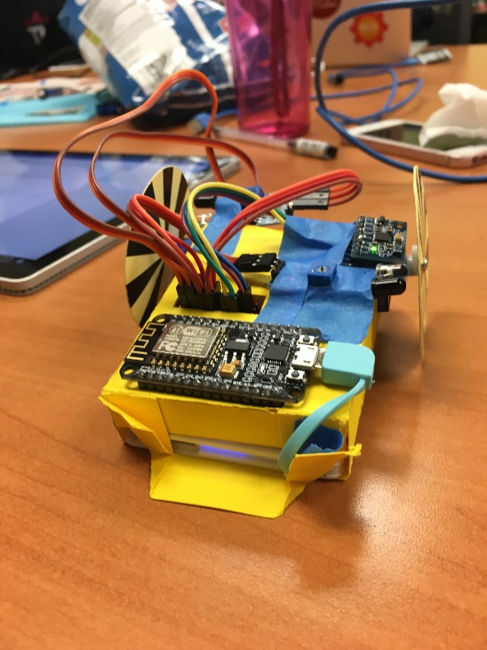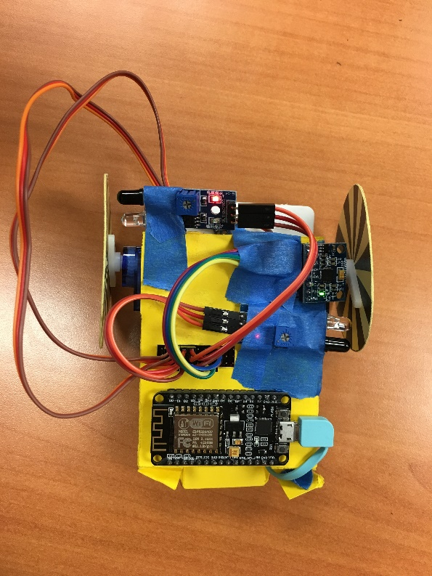

Figure , real two-wheel paper-bot

Sensor Connections

For this lab we used IR reflection sensor and gyro scope, the IR reflection sensor will measure the IR reflection, since the reflectivity will vary based on the reflection surface, white has the maximum reflectivity while black has minimum reflectivity, since our wheel is coded by black and white stripes, this sensor can measure the how many revolutions that the wheel spin and hence measure the angular speed of the wheel. The set-up for this sensor is easy, we just connect to a digital pin of microcontroller and use the digitalRead() function to read the measurement from the sensor. However, this method cannot measure the direction of rotation, so we need other mechanism to get this data. 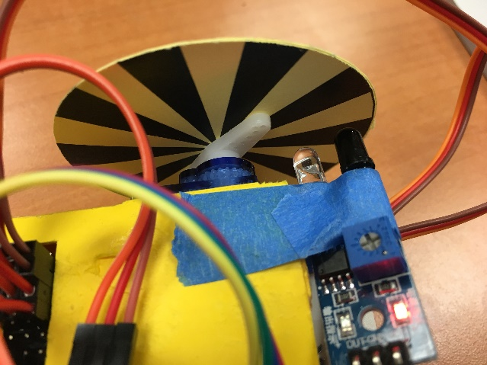

Figure Ir sensor on the robot

The gyro scope can measure the translational acceleration in three different axis and the angular velocity in three axis. This sensor use I2C protocol to communicate with microcontroller and has some bias and scaling factor need to be consider, the set-up for gyro scope is not easy,

Code,

Extended Kalman Filter Model,

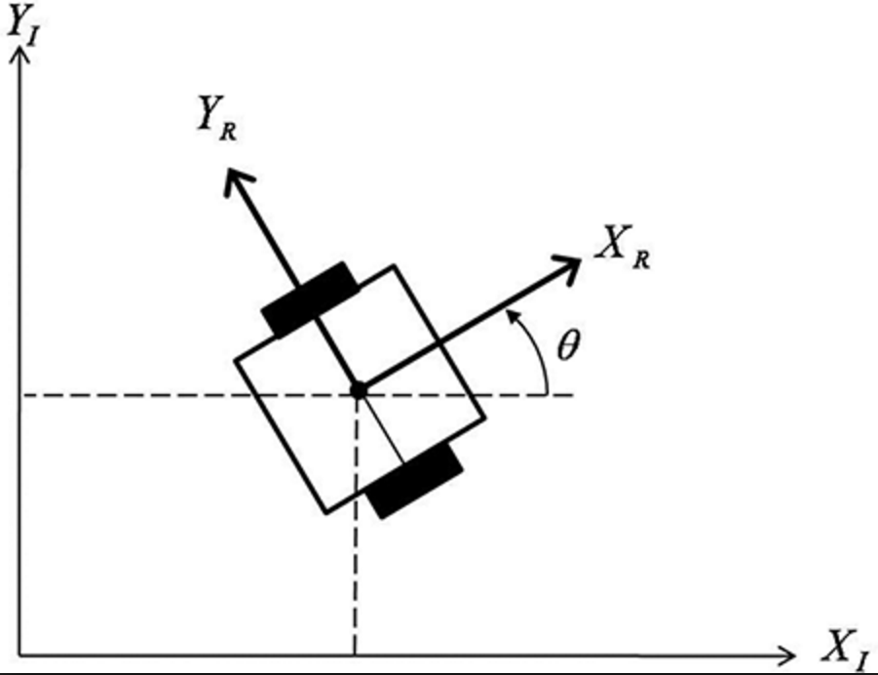

Figure 3 simplified model in 2D plane

Robot’s state can be represent as a vector that has 6 variables namely, Vx, the current velocity in x-axis, Vy, the current velocity in y-axis, Vθ, the angular velocity around z-axis, X, the coordinate alone x-axis; Y, the coordinate alone y-axis; and θ the angular position about x-axis.

Current state X(k) = $\begin{matrix}Vx \\ Vy \\ \begin{matrix}Vθ \\ X \\ \begin{matrix}Y \\ θ\end{matrix}\end{matrix}\end{matrix}$

The control signal is the velocity of two wheels (PMW output)

Control signal $u\left(k\right)=\begin{matrix}V1 \\ V2\end{matrix}$

Then we can build out model for theoretical state transition, out current state depends on the previous state plus the effect brought by the control signal during one time-period.

We can write the equation that

$$X\left(k\right)=A*X\left(k-1\right)+B*u\left(k\right)$$

since without input signal, the robot will stand still at current position and all velocity should be 0

$$X\left(k\right)= \begin{matrix}0 \\ 0 \\ \begin{matrix}0 \\ X(k-1) \\ \begin{matrix}Y(k-1) \\ θ(k-1)\end{matrix}\end{matrix}\end{matrix}+B*u\left(k\right)$$

So, A = $\begin{matrix}0 & 0 & 0 & 0 & 0 & 0 \\ 0 & 0 & 0 & 0 & 0 & 0 \\ 0 & 0 & 0 & 0 & 0 & 0 \\ 0 & 0 & 0 & 1 & 0 & 0 \\ 0 & 0 & 0 & 0 & 1 & 0 \\ 0 & 0 & 0 & 0 & 0 & 1\end{matrix}$

For B matrix we make a approximation that the time interval we use is very small, so if the velocities for two wheels are not equal, the robot supposes to drive as a curve trajectory, here we approximate this curve for a linear motion.

$$Vx=\frac{d}{2}\left(V1+V2\right)cosθ$$

$$Vy=\frac{d}{2}\left(V1+V2\right)sinθ$$

$$Vθ=\frac{V1-V2}{d}$$

$$X(t)=Vx*t+X(k-1)$$

$$Y(t)=Vy*t+Y(k-1)$$

$$θ\left(t\right)=Vθ*t+θ(k-1)$$

As we can see, this is not a linear function, so we can’t take inverse matrix of this, for that reason, we need to use Extended Kalman Filter for this lab that linearize those functions as we estimate our states.

Then we need to build sensor model for our robot. For this lab, we are using two IR reflection sensors for each wheel and a gyro scope just for angular velocity in around z-axis. So our measurement vector will contain 3 value namely Vl, velocity of left wheel, Vr, velocity of right wheel, and Vθ, which is angular velocity measured by gyro scope,

$$z\left(k\right)=\begin{matrix}Vl \\ Vr \\ Vθ\end{matrix}$$

For the model in Kalman filter, $z\left(k\right)=C*x\left(k\right)+v(k)$, where z(t) is sensor measurement which is some representation of current state, v(t) is the sensor noise.

Since our sensor has only 3 measurement for the 6 states robot, we can’t conclude the matrix C in a single matrix, to simplify out problem, we assume our input signal has only 6 commands, so we can use different C matrix based on different input signal.

If the control signal is forward or backward, the car is doing only translation motion, the C matrix is

$$C= \begin{matrix}\frac{Vx}{\sqrt{{Vx}^{2}+{Vy}^{2}}} & \frac{Vy}{\sqrt{{Vx}^{2}+{Vy}^{2}}} & 0 & 0 & 0 & 0 \\ \frac{Vx}{\sqrt{{Vx}^{2}+{Vy}^{2}}} & \frac{Vy}{\sqrt{{Vx}^{2}+{Vy}^{2}}} & 0 & 0 & 0 & 0 \\ 0 & 0 & 0 & 0 & 0 & 0\end{matrix}$$

The next class of situation is when only one wheel spinning.



For the situation that left wheel stand still while right wheel move forward, the robot is turning left



$$C= \begin{matrix}0 & 0 & d & 0 & 0 & 0 \\ 0 & 0 & 0 & 0 & 0 & 0 \\ 0 & 0 & 1 & 0 & 0 & 0\end{matrix}$$

Where d is the distance between two wheels, which is 8.5cm.



For the situation that left wheel stand still and right wheel go backwards, the robot is backing and turning left



$$C= \begin{matrix}0 & 0 & -d & 0 & 0 & 0 \\ 0 & 0 & 0 & 0 & 0 & 0 \\ 0 & 0 & 1 & 0 & 0 & 0\end{matrix}$$

For the situation that left wheel go forward and right wheel stand still, the robot is turning right



$$C= \begin{matrix}0 & 0 & 0 & 0 & 0 & 0 \\ 0 & 0 & -d & 0 & 0 & 0 \\ 0 & 0 & 1 & 0 & 0 & 0\end{matrix}$$

For the situation that left wheel go backwards and right wheel stand still, the robot is going backward and turn right



$$C= \begin{matrix}0 & 0 & 0 & 0 & 0 & 0 \\ 0 & 0 & d & 0 & 0 & 0 \\ 0 & 0 & 1 & 0 & 0 & 0\end{matrix}$$

Then , the next class of situations are two wheel spinning in different direction.

For left wheel go backward while right wheel go forward.



$$C= \begin{matrix}0 & 0 & d/2 & 0 & 0 & 0 \\ 0 & 0 & d/2 & 0 & 0 & 0 \\ 0 & 0 & 1 & 0 & 0 & 0\end{matrix}$$

For left wheel go forward and right wheel go backward,

$$C= \begin{matrix}0 & 0 & -d/2 & 0 & 0 & 0 \\ 0 & 0 & d/2 & 0 & 0 & 0 \\ 0 & 0 & 1 & 0 & 0 & 0\end{matrix}$$

When the robot is not moving



$$C= \begin{matrix}0 & 0 & 0 & 0 & 0 & 0 \\ 0 & 0 & 0 & 0 & 0 & 0 \\ 0 & 0 & 0 & 0 & 0 & 0\end{matrix}$$

Then we can compute the Kalman Gain for the Kalman filter, Kalman filter is the filter is using the predicted state and sensor measurements to best estimate the robot state.

The prediction model is

$$\tilde{X}\left(k\right)=A*\tilde{X}\left(k-1\right)+B*u(k)$$

$$P_{k}=A*P_{k-1}*A^{T}$$

Where $\tilde{X}\left(k\right)$ is the estimated current state of robot, and $P_{k}$ is the error factor for the model. Then we can recursively update the model and our estimation.

The update model is

$G_{k}=P_{k}C^{T}{(CP_{k}C^{T}+R)}^{-1}$

$$\tilde{X}\left(k\right)=\tilde{X}\left(k\right)+G_{k}*(Z_{k}-C\tilde{X}\left(k\right))$$

$$P_{k}=(1-G_{k}C)P_{k}$$

Where $G_{k}$ is the Kalman Gain for our model, $\tilde{X}\left(k\right)$ is the updated estimation of current state. And R is covariance matrix of sensor noise. That will minimize the influence by sensor noise. That is the complete model for out Extended Kalman Filter.